Take Devices. (WRT300N Router,Smartphone-PT,TabletPC-PT,3PC and 3 Routers.)

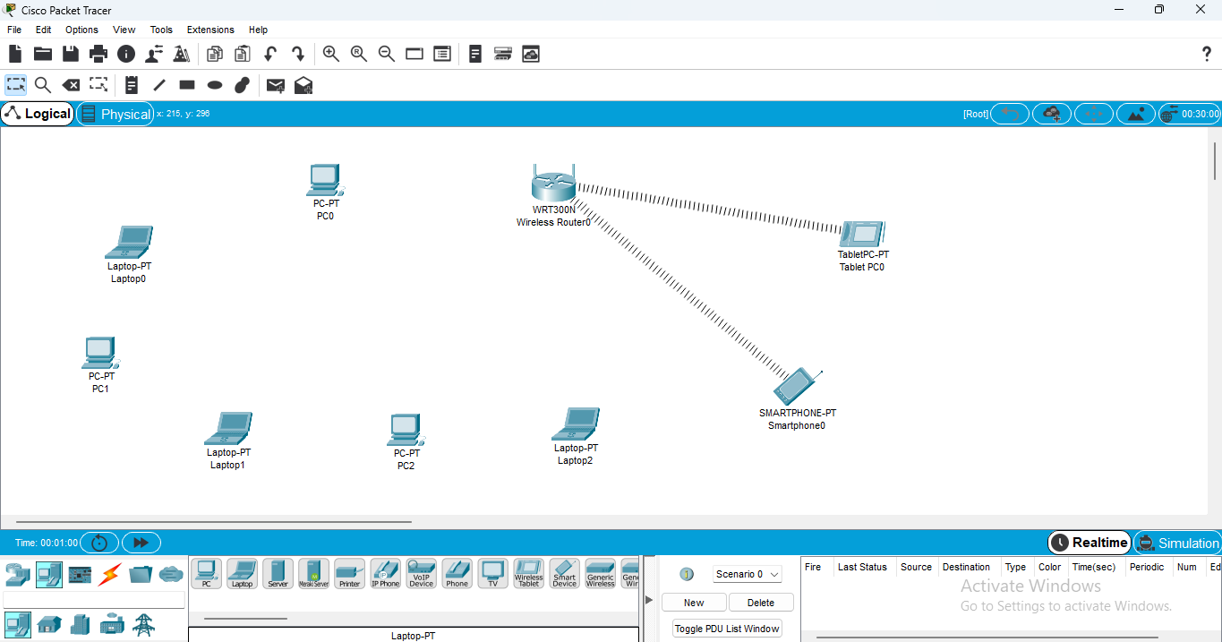

Select PC-Physical-CPU Off-Remove Port and Add Default-Port(For each PC.)

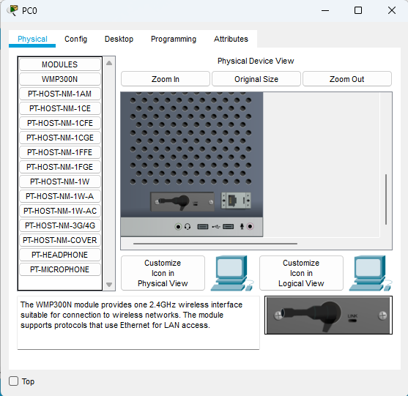

Select Laptop-Physical-Switch Off-Remove Port and Add Default-Port(For each Laptop.)

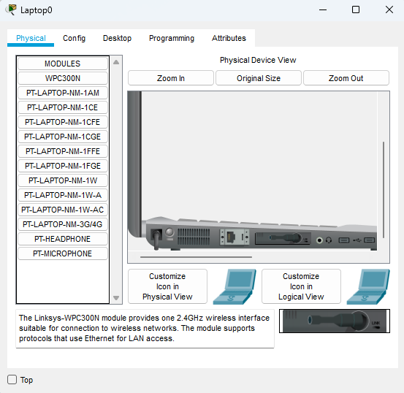

Select PC-Config-Wireless0-Copy MAC Address.(For each device.)

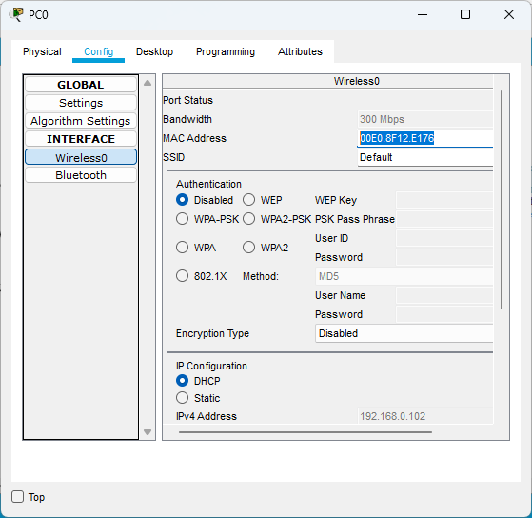

Select Wireless Router-GUI-Wireless-Wireless MAC Filter-Enabled.

And Select Option for Permit PC’s to access wireless network.

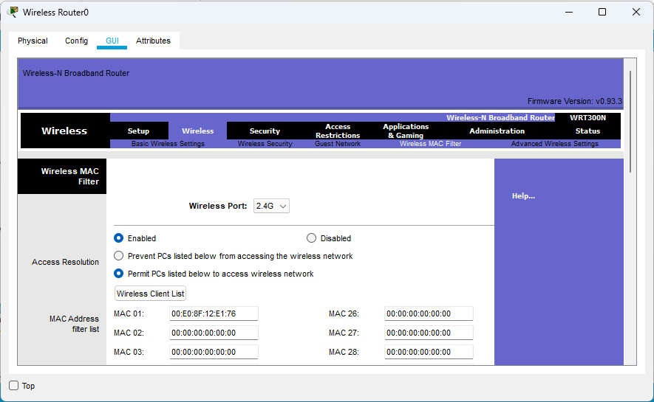

All Wireless Client List.(List of devices whose MAC addresses are added to access wireless network.)

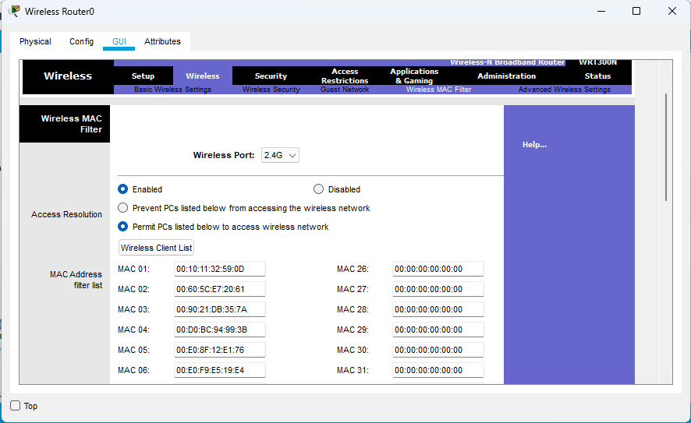

Packet Send Successfully.

